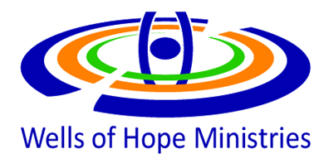

**A REPORT** **ON ANNUAL HIV & AIDS SEMINAR FOR FORMERLY INCARCERATED PEOPLE**

**18TH JUNE,2025**

**THEME: UNITING TO END HIV & AIDS; EMPOWERING FORMERLY INCARCERATED PEOPLE TO TAKE THE LEAD IN PREVENTING FURTHER TRANSMISSION**

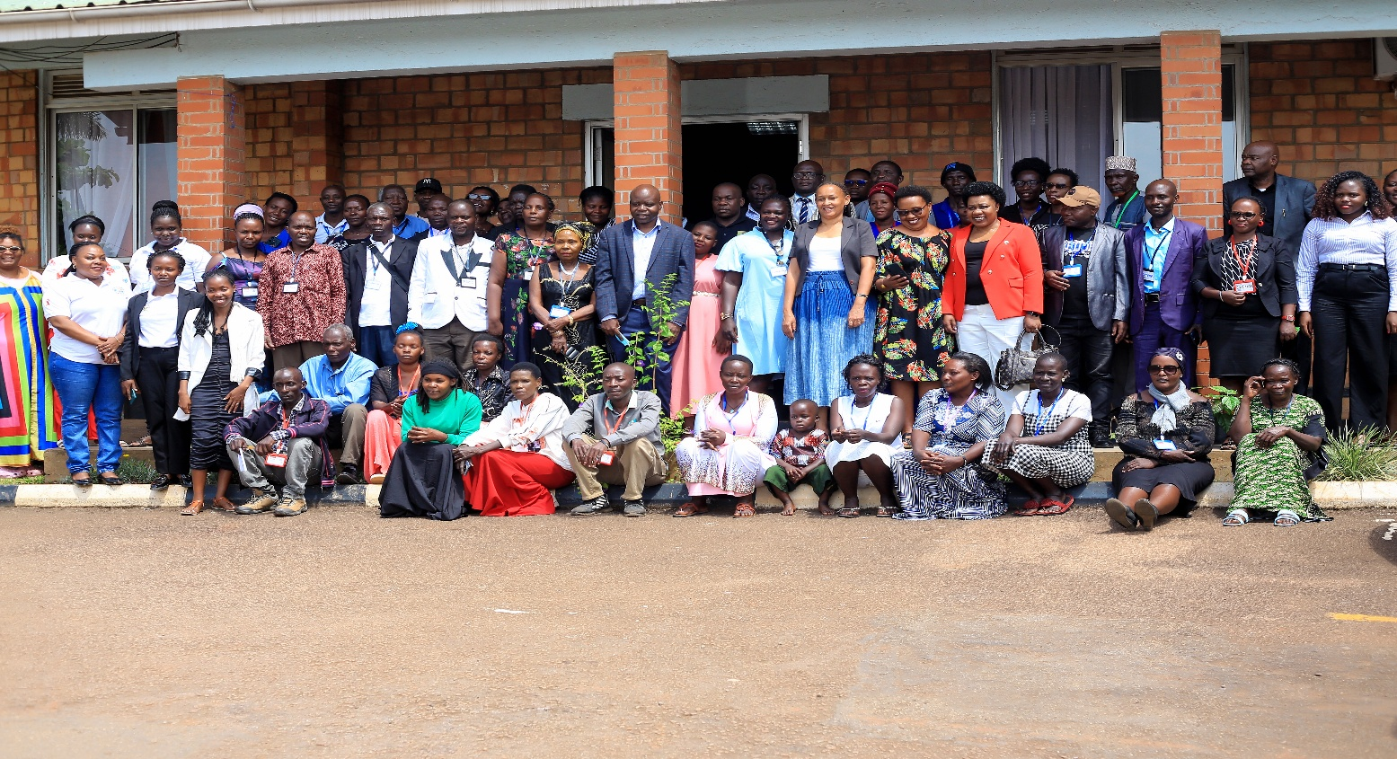

**1.0 Preamble**

Wells of Hope Ministries was privileged to organize the 2nd HIV &AIDS event for formally incarcerated people. In attendance were 83 participants among whom were 53 and 30 Men and 11 service provides. The theme was “***UNITING TO END HIV & AIDS; EMPOWERING FORMERLY INCARCERATED PEOPLE TO TAKE THE LEAD IN PREVENTING FURTHER TRANSMISSION”.***

WOHM partnered with different organizations like TASO Uganda (The Aids Support Organization), Uganda AIDS Commission (UAC), Vision Group, Power FM and Kampala Kolping Hotel.

The Guest of Honor was Dr. Sarah Bireete, a founding Partner and Executive Director for Center for Constitutional Governance (CCG), a Uganda Constitutional Watchdog and as well as a formally incarcerated. In her talk she discouraged participants from allowing their past experiences to define who they are. With illustrations and tapping from own lived experiences, she encouraged them to discover their strengths and talents, so that when their names are mentioned, people think of something beyond just their past.

***Some of the key things discussed included; -***

1. What is HIV & AIDS
2. How HIV & AIDS is spread and prevented
3. Experiences/testimonies of People Living with HIV & AIDS (PLWAs)
4. HIV Testing and Counseling
5. HIV Materials Distribution
   1. **Presentation on HIV/AIDS by Dr. Andrew**

HIV stands for Human Immunodeficiency Virus. It is a virus that attacks the body's immune system, specifically targeting CD4 cells (a type of white blood cell that helps fight infection). If left untreated, HIV can progress to AIDS, which stands for Acquired Immunodeficiency Syndrome. AIDS is the most advanced stage of HIV infection, where the immune system is severely damaged, making the body vulnerable to opportunistic infections and certain cancers. Dr. Andrew further explained that if people take medication as prescribed it that prevents HIV from progressing to AIDS.

He further explained that in Uganda, the HIV prevalence among adults (15-49 years) is estimated to be 5.8%, with women having a higher prevalence (7.2%) than men (4.3%). In prison it’s estimated at 13% making it very relevant have such a training.

Through a very interactive session, he discussed the various ways people acquire HIV & AIDS and noted that most people acquire HIV through having unprotected sex, sharing sharp items like needles, syringes, or other drug injection equipment.

In line with HIV and AIDS prevention, he encouraged the participants to practice safer sex, avoid sharing needles, and taking medications like Prep and PEP when appropriate. To those living with HIV, he emphasized taking antiretroviral therapy (ART) to prevent transmission to others. He further stressed that strict adherence to ART also enables formerly incarcerated people to live longer and healthier.

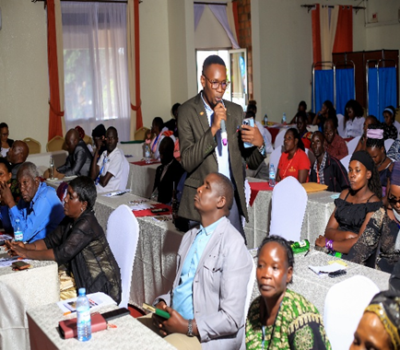

**Figure 1:** Dr. Andrew delivering his presentation on HIV/AIDS

**1.2 Presentation on HIV & AIDS Testing and Counselling (HCT)**

Emphasis was also put on HIV Counseling and Testing as an entry point into treatment, care and support. The participants were made aware that knowing their HIV status has several importances that included; allowing one to access treatment early, which improves their quality of life and reduces the risk of transmission. It was emphasized that testing is voluntary no one is forced to test for HIV. The team of professional health workers to do this activity was constituted with all necessary facilities brought. Participants were advised that if they test positive for HIV, it is critical to begin ARV (antiretroviral) treatment immediately and continue taking the prescribed medication as directed by a healthcare provider.

At least 43 people tested for HIV & AIDS and out of these 33 were living with HIV. They received counselling and encouraged to live positively. It was further emphasized that adherence to the treatment plan made between the health worker and the client is essential for managing the condition effectively and preventing further transmission to others.

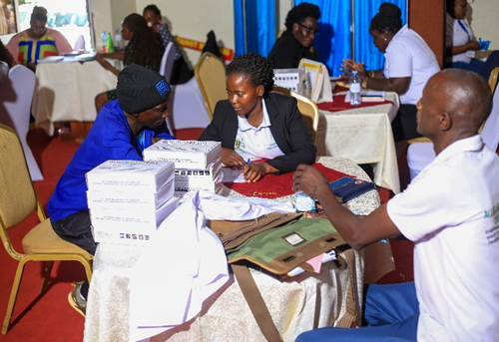

**Figure 2:** Practical HIV Counselling and Testing sessions in progress

* 1. **Experiences/testimonies of People Living with HIV & AIDS (PLWAs)**

An opportunity was given to different participants to share their lived experiences in relation to HIV/AIDS as a means to encourage, build confidence and support others to cope and live positively. In this regard, two people shared their journeys of Living with HIV & AIDS and encouraged those living with HIV & AIDS to continue taking their medication so as to be able to live longer and healthier.

**1.4 Highlights from Participants’ Testimonies**

Okello 35 years said***; ‘‘thank you Wells of Hope for organizing such an event, to be honest I have always wanted to test for HIV & AIDS but had unknown fears but today, I am happy to have tested and known my HIV Sero status”.***

Janet 27 years had this to say; ***“I didn’t know that anything like Prep existed, I am glad I came. You have educated me and got free knowledge about HIV/AIDS and the new developments”***

Fredrick 33 years**,” *Thank you for availing us with these materials; I am going to share with my wife and all the people around me. This knowledge can’t end with me”.***

Sarah 47 years, **“*I have always wanted to test but somehow I couldn’t, today I have made the decision to test and I am negative, I am going to take good care of myself’’*.**

David 44 years; **“*Thanks you so much for availing us with the condoms, I always feel shy to go buy them from the shops in our community*”.**

**1.5 Questions and Answers Session**

1. How long does HIV take to pull down a person?
2. Can one die if they stop taking medication but later restart?
3. Is Hepatitis B the same as HIV?
4. When prisoners are tested and one is found positive, do they inform their wives?
5. Can one get TB without being infected with HIV?
6. How come some babies are born with HIV?
7. Can an HIV-positive person retest?

**1.6 Key Achievements from the Event**

1. The turn up was very good we expected 100 people and received 83
2. At least 43 people tested for HIV & AIDS
3. The participants were very active and the event was very engaging.
4. Referrals were made for people who tested positive with HIV.
5. Correct information on HIV & AIDS was given to the participants which helped participants to learn and unlearn certain things related to HIV/AIDS.
6. IEC materials with HIV/AIDS messages were shared with participants.

**1.7 Challenges**

1. Distance for most of the people
2. There is a lot more participants wanted to know about HIV/AIDS but the time was limited.
3. We expected 100 participants but only 83 turned up and the hotel refused to adjust.

**1.8 Appreciation and Acknowledgment**

We would like to appreciate A new way of Life for enabling us to conduct such an event.

We appreciate the facilitators in this session who shared their professional perspectives related to the topics and sessions in the event.

Participants are also appreciated for their time, lived experiences shared and comments made that made the event more engaging and interactive in nature.

Lastly, Wells of Hope, TASO, UAC are also appreciated for their efforts to make this event colorful.

Edith Alituha

Social Worker- WHO Women’s home

END