**REPORT**

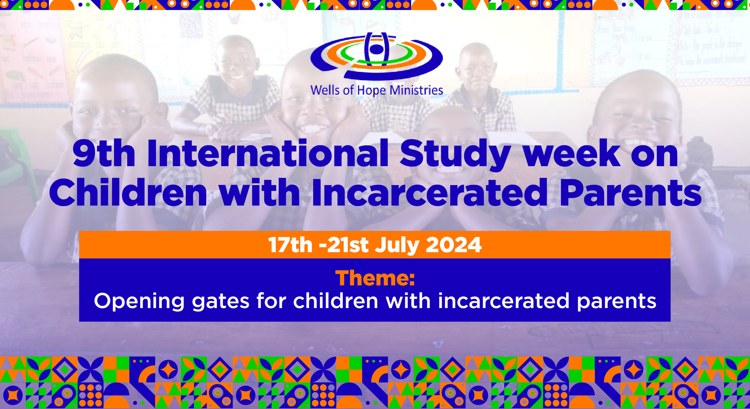

The 9th International Study Week on Children with Incarcerated Parents 2024 at Wells of Hope Ministries was a week of interacting with children with incarcerated parents, their families and the inmates.

The International Study Week was a 5-day event which was organized by Wells of Hope Ministries, where participants from different parts of the world were engaged on a study about children with a parent in prison.

**vision**

A society where people, especially children affected by the criminal justice system get justice and regeneration in their lives

**Mission**

To address needs of inmates and their families, with great attention given to children with a parent in prison through sustainable and compassionate programs

**Mandate**

To be compassionate by responding to needs of inmates and their families

The program was as below;

**DAY 1** - Meet the Wells of Hope staff team.

Visit Wells of Hope Ministries offices; 9:00am

* Head Office9:30am
* Safe Home11:00am
* Family Based Care Project 12:00pm
* Lunch at Safe Home 1:00pm

**DAY 2-** Visit Uganda’s Maximum Security Prison.

* Luzira Upper Prison 9:30am
* Luzira Women’s Prison 12:00pm

**DAY 3-** Visit Wells of Hope Schools (Whole day)

* Meet and interact with the children with incarcerated parents.
* Get to hear the children’s stories.
* Panel discussion

**DAY 4** – Community family Visit (Whole day)

-Visit remote villages and isolated old people taking care of children of incarcerated parents.

-Meet families and rural communities helped by Wells of Hope.

**DAY 5** – Round Table discussion (safe home) 9:00am

**THE PARTICIPANTS**

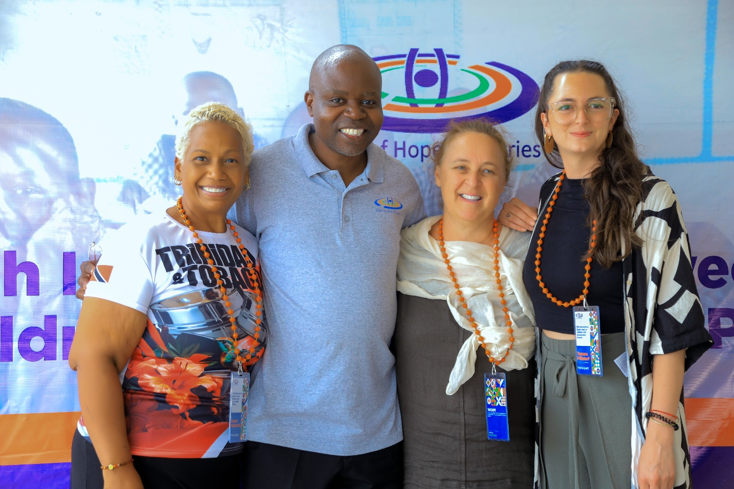

***Mr. Ssuubi Francis WOHM Founder with Karene Nathaniel (Trinidad & Tobago), Katie Kramer(USA) & Tamara Fillistorf (Switzerland) 2024 9th International Study Week participants.***

**Dr. Nathaniel** **Karene-Anne Jacinta Decaires**

Dr. Nathaniel Karene-Anne Jacinta DeCaires is a lecturer in Social Work at the University of the West Indies, Trinidad and Tobago and serves as the Deputy Dean for Undergraduate student matters in the Faculty of Social Sciences. Over her nearly 20 years in higher education, she has been fully committed to Social Work and social justice education, in particular building social work identity, reflexivity and competence in professional practice in the Caribbean with all vulnerable populations including children and youth at the margins, survivors of violence and trauma and disenfranchised communities such as persons impacted by incarceration and mental health challenges.

**Katie Kramer**

Katie Kramer, DSW, MSW, MPH, is the Co-Founder and CEO of Communities and Families for The Bridging Group.  For the past 25 years, she has focused on developing, implementing, and evaluating social services and health programs that serve individuals, families, and communities affected by the criminal legal system. Dr. Kramer has worked with governmental, non-governmental organizations and research/academic institutions working in correctional facilities or community reentry throughout the United States and globally with projects in Haiti, Kazakhstan, Kenya, Kyrgyzstan, Russia, Tajikistan, Trinidad, Ukraine, and Uzbekistan. In addition, Dr. Kramer currently serves on the Board of Directors for the International Coalition for Children with Incarcerated Parents, on the National Advisory Board for Urban Institute’s Prison Research and Innovation Initiative, and on the Executive Editorial Board as a Criminal Justice Expert for the Journal of Clinical Research in HIV/AIDS and Prevention.

**Tamara Fillistorf**

Tamara live and work in Geneva, Switzerland. She is a social worker at the "Foundation Relais Enfants Parents Romands (REPR)." Which support families, especially children, with a parent in jail by organizing activities, discussing their circumstances, and assisting families outside social institutions. It facilitates visits to incarcerated parents, if it is the best interest of the child, and hold discussion groups in prison for parents to share their experiences.

She is very passionate, enthusiastic, and very curious.She is thrilled to work with people and to meet individuals with diverse life stories and lifestyles every day. She was very excited to be part of the Study Week in Uganda. I can't wait to meet you, colleagues, and the families.

**ONLINE PANEL DISCUSSION PARTICIPANTS**;

**Benjamin Raikes**

He is a social worker lecturerer at Huddersfield University in England for 14yrs and over that time, he has been researching the impact of imprisonment on families and children. He attended the study week in 2013, he was encouraged by Dr.Adele Jones and it was a profound experience for him as well. Through INCCIP, working with Wells Of Hope Ministries founder and Nancy Louck on a project on looking at how schools and prisons collaborate in a broader context.

**Nancy Louck**

She has an academic background as well.She went to the institute of Criminology in Cambridge. She is originally from the USA. She has been in the UK for 35yrs. She enjoys learning about global issues;how people cope with these issues in different countries especially the issue of children with incarcerated parents. She has been with families outside for 16yrs now.

**Sarah Kruger** (From Kenya)

**Jonah Ogwayu** (From Uganda) works with Somero Uganda

**Dr. Derek Sekindi**(From Uganda) works on the Human Rights and criminal justice issues.

**IN-PERSON** **PANEL DISCUSSION PARTICIPANTS**;

**Francis Ssuubi** (Founder Wells of Hope Ministries)

**Marjorie Lunkuse Lwanga** (Deputy Executive Director Wells of Hope Ministries)

The participants arrived on the 16th July. On the 17th the visited the administrative stations of Wells of Hope Ministries; Head Office, Family Based Care Office and Wells of Hope Women’s Home. On the 18th they went to the prisons (Luzira maximum security). On the 19th they visited the schools where they got to meet the children and the different activities that the children do. On the 20th they visited the families in the community and villages; they went to the families in Luweero.

**OVERVIEW OF THE PARTICIPANTS EXPERIENCE;**

Karene came in for the study week not to directly with the children and parents but to see what she can teach social workers; encourage social workers into doing but she saw her coming as an opportunity to learn from another developing country which has limited resources but yet has been able to create this slate of programs. She came with that vision and she was not disappointed by the incredible breadth of work that occurs.

The commitment of the social work staff was extremely humbling to her, she made friends that were dedicated to showing them the work that they do, and they did so with a smile and it was tremendous to experience and incredibly humbling. The work of WOHM is so responsive to the needs that emerged; the organization has learned more and more about what children and their families need, children and families who are affected when parents are incarcerated, what their needs are, no matter how farfetched or how unbelievable the need is, they have found a way to respond to that. It started off with the children having trouble with schooling. They have responded by building schools, having accommodation available in these residential schools. And then, it became well; there some children who it’s not feasible for them to be in their family, so to go home during the holidays. And so the Family based care program kind of started.; and this was their kind of understanding of it. And then there is a challenge with women when they are released from prison, not having anywhere to go and so the safe home was created out of that. And then their women who have some injustice, there may be some injustice that is keeping them in prison so they now have legal suites, legal aid services that help to support those women for them to be released from prison because their families and or their children are really struggling when they are away. So the responsiveness of the organization is the thing that the participants went away with.

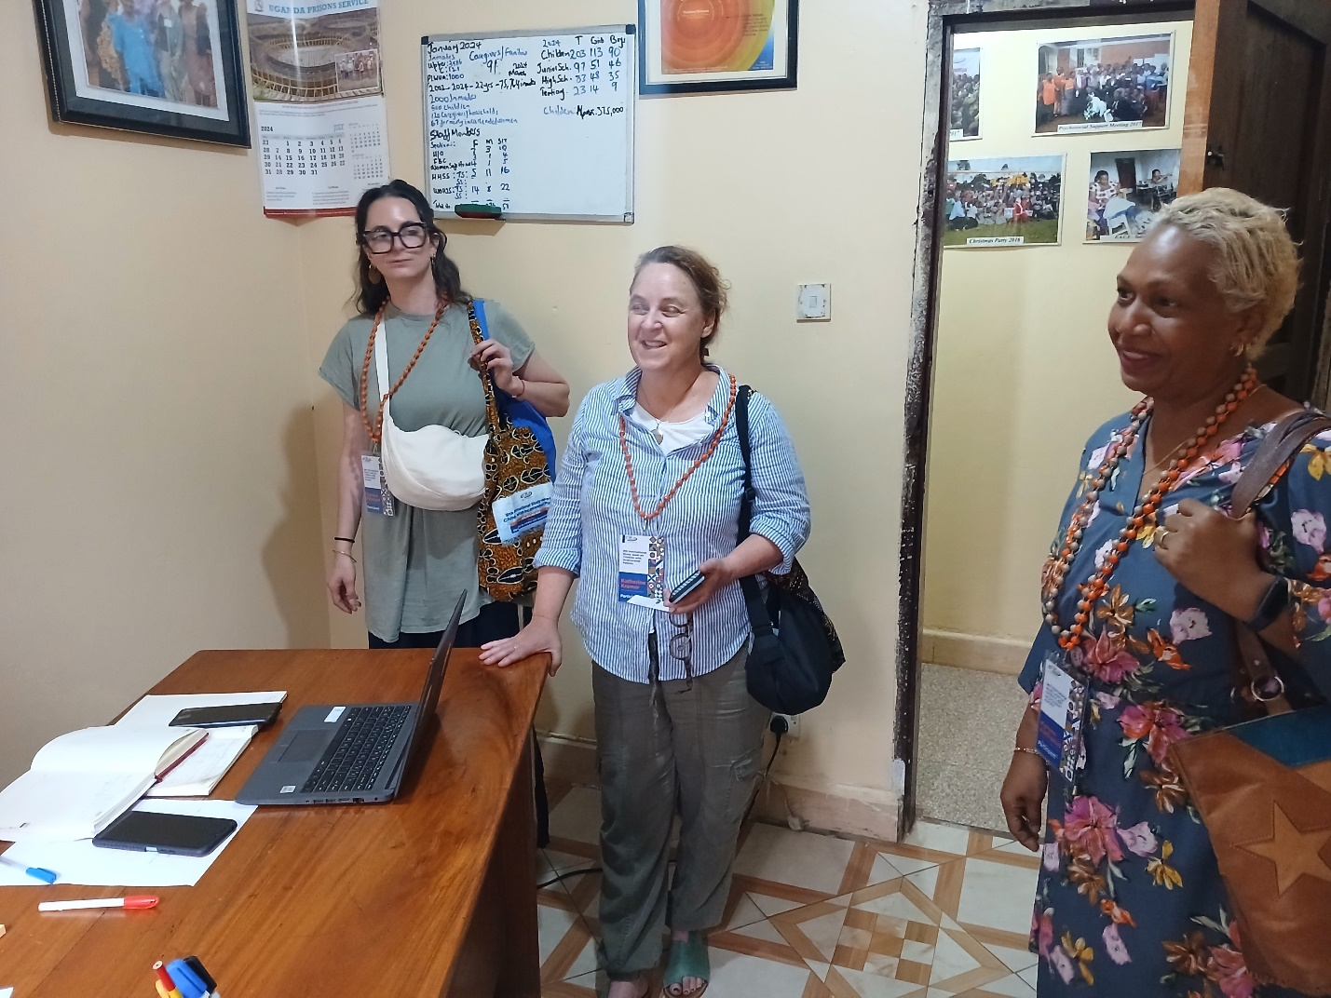***Participants in the WOHM Executive Director’s office at Head Office***

The other days of going to the prison, going to the schools and going to the families helped them to understand the grand context with in which WOHM support is doing this week. Who are these parents in prison and what their conditions and how are they thinking about the needs of their children and families? Who are these children? Seeing the faces of the children and the joy on their faces is just priceless. Who are these families, where are they? And who are the social workers, and what are they doing and what do they have to do in order for this program to be what it is, and for the goals and the dream that the vision that has been set before them to be achieved and their work is. It’s just nothing short of miraculous in their view.

For Katie, the study week was one of the true top highlights of her professional journey and her motherhood journey; it was unbelievable. She has been working with and for families impacted by criminal justice systems for almost 30yrs. And this week was such a highlight.

The biggest highlights are the deep learnings. Families across the world experiencing similar challenges. And that was so much reinforced and envisioned and seen here in Uganda, and at the same time really understanding while some of the issues and challenges are similar across the world, that each individual child and family really has their own unique story and how it plays out and how these impacts play out for children. Families really do differ based on different countries, resources and systems and that came to life so much more deeply this week. It was their first time to Uganda, learning and appreciating Uganda and how Uganda is so special to this world, the music in the prison stood out for them it was unique. Dancing with the children at school, the dance party was a highlight; it was warm and beautiful and family and unifying and celebratory.

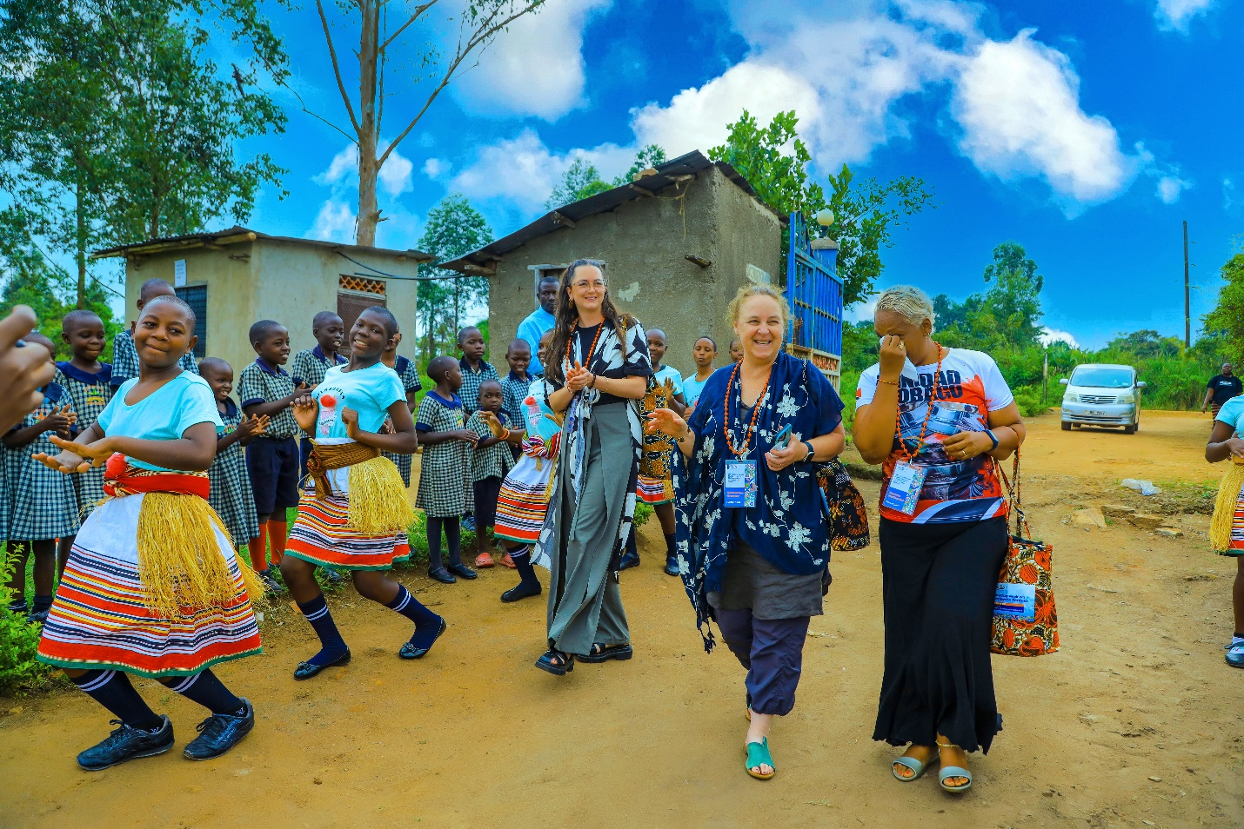***The participants being welcomed at WHO Junior school by the students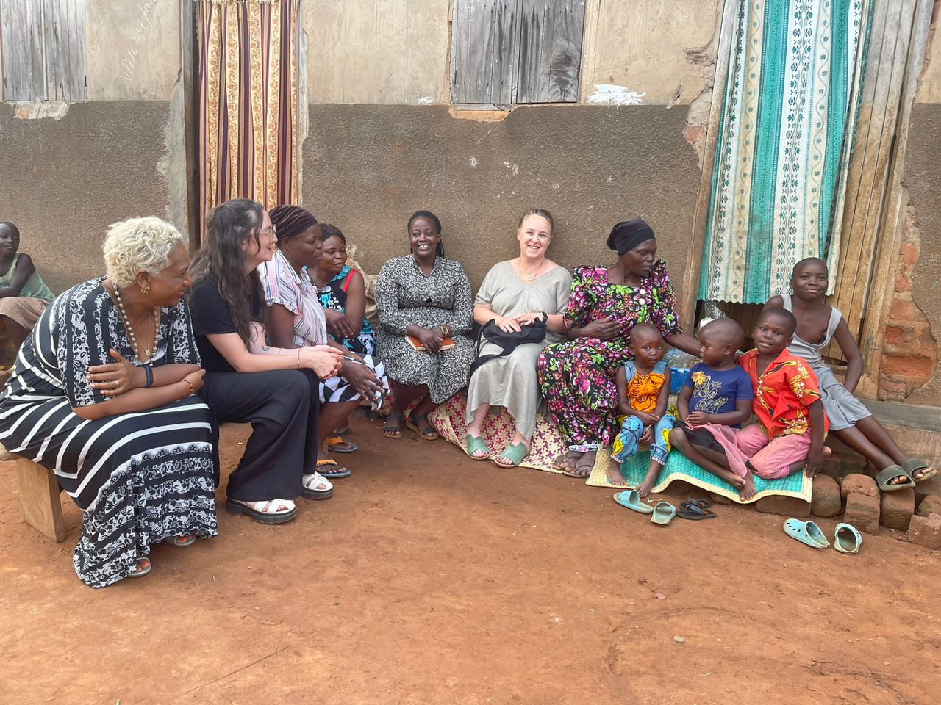The participants and the social worker visiting one of the families in Luweero***

The other thing she went away with was understanding so much is often said but seeing and experiencing what is said to the participants by far the young people at WOHM really understanding and appreciating them; not much, just for the challenges. Young people have many challenges and very tough things happen to them, but they are incredibly strong, smart and passionate young people. In one of the panel the young people each introduced themselves as activists and they are; it was mind blowing and out of that, one of her biggest commitments is figuring out how to walk, the walk of centering the leadership and the voice of all this week and of the young people because they really are the experts and they are. They articulated and spoke to the challenges and solutions in a very incredible inspiring way and it was their most dominant impression for the week; How do we walk? The walk of settling the work and really passing on the work with the support that the young people need to also really center the work with them as the leaders and to really celebrate their strengths along with understanding what we are pursuing.

**HIGHLIGHTS:**

**Note:** Each day for them had a highlight but to mention but a few.

* Understanding the breadth of the work that WOHM does and really understanding the approach.
* Going to community and meeting with the beneficiaries.
* Meeting all the staff was wonderful and hearing the list of services but then seeing the staff in action over the next days, really made it clear just how hard the staff is working and how much that is to when we see all the needs and then we want to respond out to the needs, how does that then plat out in the day to day work of the staff and how does that then play out in the day to day work of the staff and how you continue to respond to the needs without burning out the staff too and really being supportive of staff.
* Being in a maximum security prison with men and women who felt safe and open enough to really share openly and honestly with in a prison environment speaks volumes to WOHM into the relationship they have created with the people to feel safe and open.
* The panels of the young people who are working to fight against the death penalty were amazing.
* The dance party with the children was heart lifting.
* The family visit was unique. They visited three families and each family had a unique story and it was very powerful.
* The welcome from the children and the children openly and generously sharing their stories was amazing. Relatedly, the confidence of the children was impressive given their circumstances.
* The children against death penalty club was impressive as well. They have strong voice, they are articulate and very organized.
* The conversations with the social workers on the road was a highlight as well giving more light on the work of WOHM and the day to day operations.
* Voices. They heard the founder’s voice which propelled them to come but when they got here they have been able to hear the voices of the beneficiaries of WOHM, the voice of the caregivers, the voice of the staff, the voice of the foster care parents, the voice of the men in prison, fathers in prison, the mothers in prison, the very powerful voice of the children. Their voices when singing and laughter and poetry, but also their voices in activism, in understanding the issues and being able to articulate them so very powerfully. The voices of the grannies, the voices of the families, the social workers and the teachers.
* The gratitude that is expressed by the people towards WOHM as a whole. They are very appreciative of the work that has been done to help them to provide for their beneficiaries; the gratitude is the greatest humility.
* The generosity of the people is unbelievable because they don’t have but they are willing to share the little they have.
* The joy everyone has and the hope even with the inmates taking joy in what is available.
* The knowledge coming from the context which is normally undervalued and the human connection.
* The enthusiasm of the social workers to make a difference in the lives of the children and the caregivers.

In terms of best practice, how do we help the children become better? The participants suggested the following;

* More resources needed to help the children.
* The impression of the young people as activists themselves. Create pathways for young people to be present in and connecting them with other activists, work and effort.

Take away; The activist movement in the USA and informing them of the work that your doing and making the connections about the death penalty activism and really tapping into what is already going on out there. A lot of that work does not have a youth voice at all, so the children’s voice is building on what is already there.

* Commit to finding pathways to connect young people all around the world. Figuring out how to really make that happen.
* Creating communities of belonging where children feel like they belong and that they are not uttered or invisible, and I saw that the school is such a community of belonging the biggest assets is really bringing them together, other young people who have parents in prison. Make the school a community of belonging where children receiving support, are growing, are getting educated, can be seen, can be heard. How do we tap into this? It’s already there in terms of voice.
* Youth involvement into activism; for example, lead a group of children to go to parliament and to make the case for more resources for children affected by parental imprisonment.
* Build more momentum around the vision and create a strong network in other countries in Africa who are likeminded. The knowledge WOHM has and what we do is social capital for those countries.

**Note:** WOHM has many basic practices that need to be highlighted and improved.

* Inter-agency collaboration is important on the ground in the location. The international collaboration is very important for stimulating kind of macro or grand thinking about this issue because what is happening here in Uganda can influence what happens elsewhere and make the needs of children with parents in prison an issue there. In order for this to succeed, we need the corporation of people and agencies on the ground. The response of WOHM has been spot-on but now the response has to be who else is working on this space that we can pull into supporting the work that we do and by so doing support them. Therefore, strengthening interconnect into agency or into organizational intra collaboration in Uganda is very critical.
* Tackle criminal justice, in equities and insufficiencies. Criminal justice reform has to consider the impact of poverty on incarceration and incarceration practices. It has to consider migration dynamics all over the world that is impacting on migration on prison imprisonment and incarceration. Dynamics, the judicial processes as impacting criminal justice, the needs of children and families to impact criminal justice, reform the and also the philosophy that we are using for law enforcement, criminal justice, the voice of the officer in charge. All the criminal justice reform can be really powerfully driven by the voice of children.

It was emphasized that intra agency collaboration is also more about recognizing that it’s not just a criminal justice issue. It is about education and health and poverty and all of these other issues. So that’s where it becomes a bigger picture but we have to start somewhere and you cannot tackle all these issue at once.

* Create an African coalition.

**Question:** How can we be helped with the African coalition?

* Have credible research on the issues that would inform an international legal instrument regarding this particular subject but lack of resources, or perhaps interest broadly in this subject has defeated that movement.
* Develop a coalition at regional or international level with support from colleagues across the globe.

Moving forward, find resources which come from the UN and it has to be founded on research, but also galvanize effort to support the development of that instrument to be founded on research.

Have a follow up webinar for further discussion of learning from the study into action. For the community tours, change the timing and how far the participants have to go in terms of distance.

Have a collaboration with other organizations doing the same work to inspire and encourage other people to come into the same space.

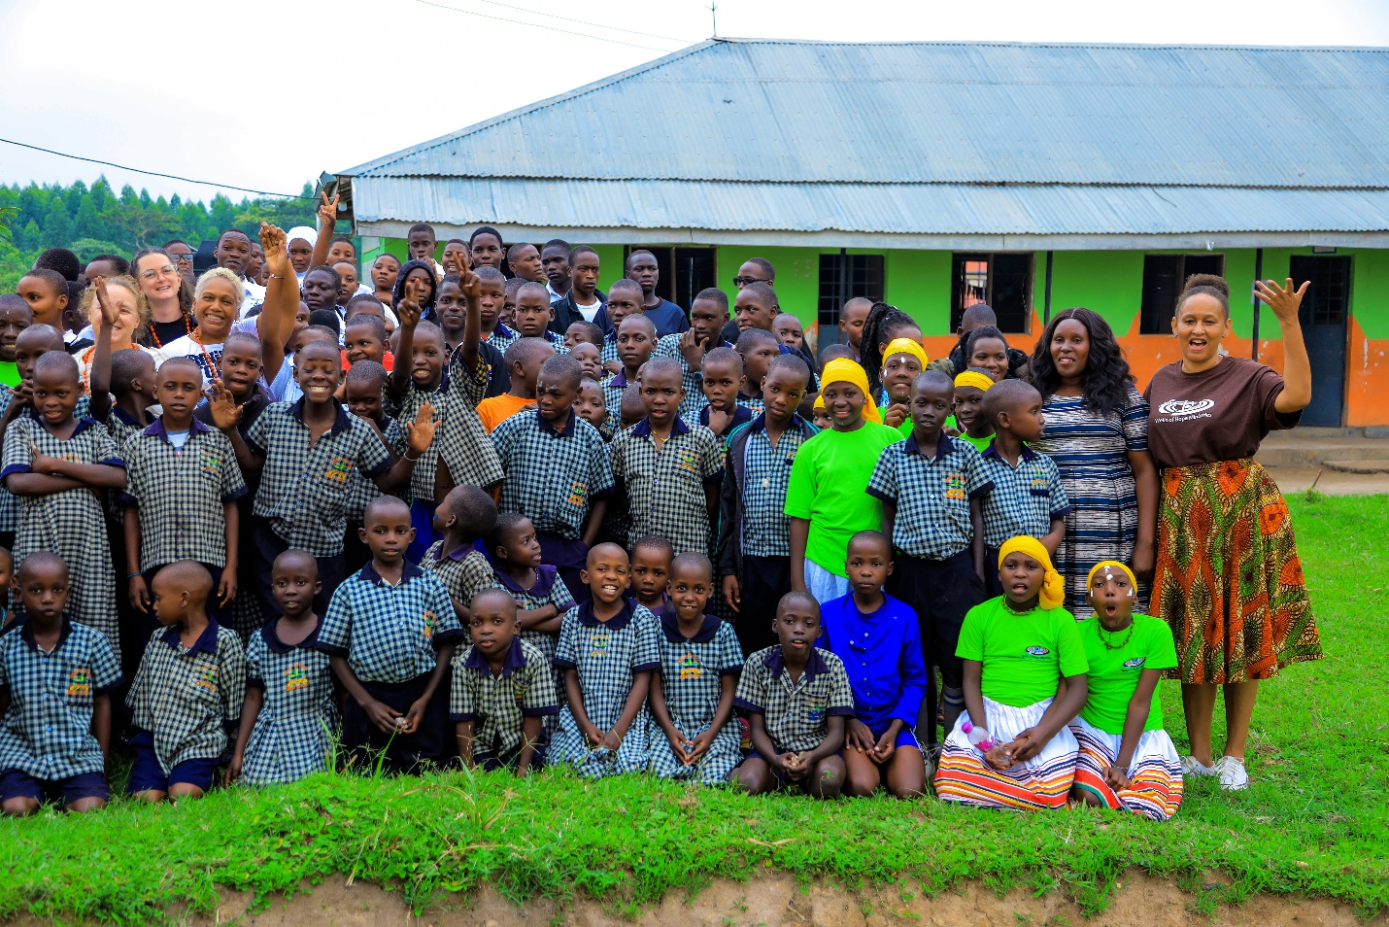

***The WOHM ED with the study week participants and the children***